**LAB 9:**  **JUNCTION FIELD EFFECT TRANSISTOR**

Name: ABDUL RAHIM BIN SAIDI (BK19110293)

**Objective:**

To study transfer and output characteristics of an n-channel Junction field effect Transistor (JFET) in Common-source configuration.

**Learning Outcomes:**

Able to analyze the characteristics of an n-channel Junction field effect Transistor (JFET) in Common-source configuration.

**Instrument/Component:**

Variable Voltage Supply

Digital Multimeter

N Channel JFET (2N3370/NTE 312/any)

**THEORY: Construction & Characteristics of JFET**

JFET(Junction Field Effect Transistor) is a three terminal device (drain, source, gate) similar to BJT. The difference between them is that the JFET is a voltage controlled device, whereas BJT is a current controlled device.

Figure 9.1 shows the 2N3370 N Channel JFET symbol and real device.

|  |  |
| --- | --- |
|  | 2N3370 Motorola IC Chips | Censtry |

**Figure 9.1**

**Drain Characteristics:**

For JFET, the relationship between an output parameter, ID, and an input parameter, VGS, is more complex. In the saturation region, there exists a square-law transfer relationship.

**Transconductance Characteristics:**

In the transfer characteristics of a two port network, the input parameter is changed and its effect on the output parameter is observed. Similarly JFET can be treated as a two-port nonlinear network. The transfer characteristics wherein the input parameter is the voltage across gate and source, and the output parameter is the drain current are called the transconductance characteristics. The transfer gain is nothing but conductance, hence the name.

**Task 1: Measuring ID versus VDS (Output Characteristics)**

1. Build the circuit as in Figure 9.2. Use the 2N3370 transistor.

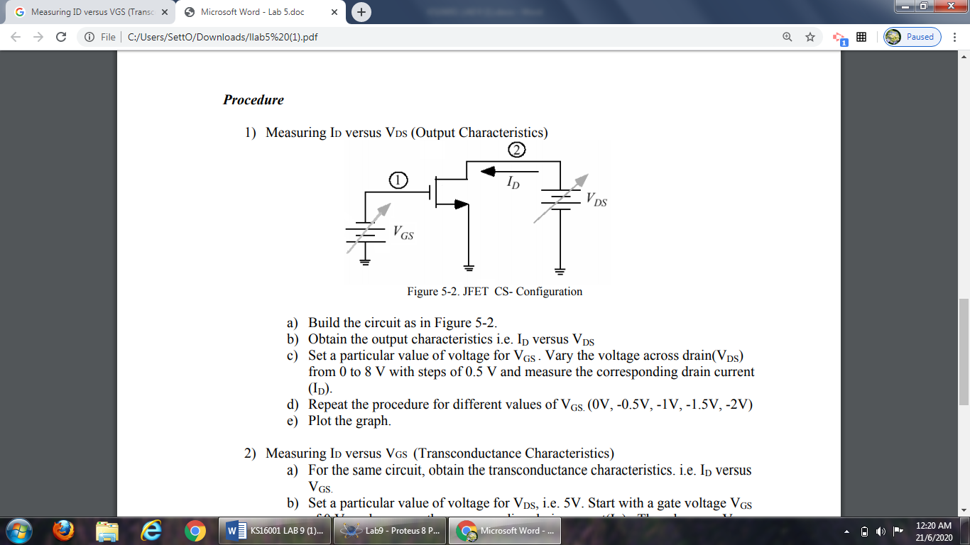

**Figure 9.2**

1. Set a particular value of voltage for VGS (i.e. 0V). Vary the voltage across drain (VDS) from 0 to 8V and measure the corresponding drain current (ID). Repeat the procedure for different values of VGS (as in Table 9.1). Record the readings in Table 9.1.

**Table 9.1**

|  |  |  |  |  |  |  |  |  |  |  |  |
| --- | --- | --- | --- | --- | --- | --- | --- | --- | --- | --- | --- |
| **VGS**  **(V)** | **VDS (V)** | | | | | | | | | | |
| 0 | 0.5 | 1.0 | 1.5 | 2.0 | 3.0 | 4.0 | 5.0 | 6.0 | 7.0 | 8.0 |
| 0.0 | **0** | **0.72m** | **0.26** | **0.74** | **1.22** | **2.21** | **3.20** | **4.19** | **5.19** | **6.18** | **7.18** |
| -0.5 | **0** | **0.31m** | **1.03m** | **0.26** | **0.74** | **1.72** | **2.70** | **3.70** | **4.69** | **5.68** | **6.68** |
| -1.0 | **0** | **0.01m** | **0.33m** | **1.05m** | **0.26** | **1.22** | **2.21** | **3.20** | **4.19** | **5.19** | **6.18** |
| -1.5 | **0** | **0** | **0.01m** | **0.33m** | **1.06m** | **0.74** | **1.72** | **2.70** | **3.70** | **4.69** | **5.68** |
| -2.0 | **0** | **0** | **0** | **0.01m** | **0.33m** | **0.26** | **1.22** | **2.21** | **3.20** | **4.19** | **5.19** |

1. Plot the graph ID versus VDS. Label the graph completely.

**Task 2: Measuring ID versus VGS (Transconductance Characteristics)**

1. Using the same circuit, set a particular value of voltage for VDS, i.e. 5V. Start with a gate voltage VGS of 0 V, and measure the corresponding drain current (ID). Then decrease VGS in steps of 0.25 V until VGS is -3V. At each step record the drain current (ID) in Table 9.2.

**Table 9.2**

|  |  |  |  |  |  |  |  |  |  |  |  |  |  |
| --- | --- | --- | --- | --- | --- | --- | --- | --- | --- | --- | --- | --- | --- |
| **VDS**  **(V)** | **VGS (V)** | | | | | | | | | | | | |
| 0 | -0.25 | -0.50 | -0.75 | -1.00 | -1.25 | -1.50 | -1.75 | -2.00 | -2.25 | -2.50 | -2.75 | -3.00 |
| 5 | **4.19** | **3.94** | **3.70** | **3.45** | **3.20** | **2.95** | **2.70** | **2.46** | **2.21** | **1.96** | **1.72** | **1.47** | **1.22** |

1. Plot the graph ID versus VGS. Calculate the transconductance parameter from the graph assuming your VGSQ value is -1 V. **Transconductance** is the ratio of change in drain current (δID) to change in the gate to source voltage (δVGS) i.e the change in drain current divided by the change in gate voltage.

**Transconductance, $g_{m}$ At $V_{GSQ}$ = -1 V,**

$g_{m}$**= $\frac{∆ I_{D}}{∆ V_{GS}}$ = $\frac{\left(4.19-2.21\right) A}{\left(0-\left(-2\right)\right) V}$ = $\frac{1.98}{2}$ = 0.99 S**

**Discussion:**

Use all of the data obtained to answer the following questions:

1. Discuss the output (Task 1) and transconductance curves (Task 2) obtained in lab? Are they what you expected?

Answer:

-If we compare the value $V_{DS}$ = 5V from $I_{d}$ vs $V_{DS}$ (right) also Graph $I_{D}$ vs $V_{GS}$ when $V_{DS}$ = 5V (left), the some of value of Id are exactly the same. Hence, it is expected.

1. Are the output characteristics (Task 1) spaced evenly? Should they be?

Answer:

-From the graph on Task 1, we can see clearly that the graph is spaced evenly on the active region but not on the ohmic region.

-The transfer and $I_{d}$  vs $V_{DS}$ characteristic curves for the JFET, differ from the corresponding curves for a BJT. The BJT curves can be represented as evenly spaced for uniform steps in base current because of the linear relationship between $I_{C}$  and $I_{B}$ .

-The JFET have no current analogous to a base current because the gate currents are zero. Therefore, we are forced to show the family of $I_{d}$ vs $V_{DS}$ curves, and the relationships are very nonlinear. Hence, it **should not be** and vary sometimes.

1. What are the applications of JFET?

Answer:

-Used as a switch, chopper, amplifier, buffer, voltage-controlled resistors in operational amplifiers.

-Used **in** the oscillatory circuits because of its low frequency drift, **in** digital circuits, such as computers, LCD and memory circuits because of their small size, **in** communication equipment’s, such as FM and TV receivers because of their low modulation distortion, **in** cascade amplifiers and in RF amplifiers.